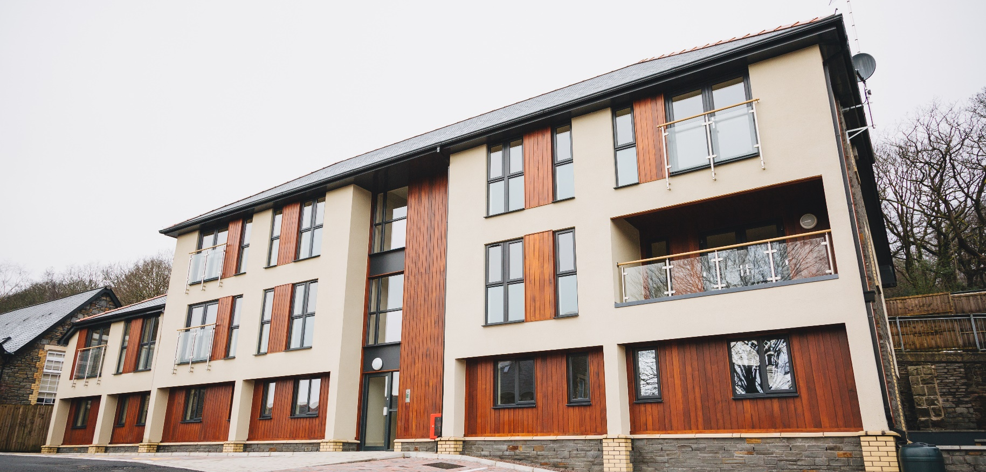
Candidate Information Pack
Building Surveyor (Futures and Innovations)

Contents

3 Letter from Luke Takeuchi, Chief Executive
4 About us
5 Advert
6 Job Description
9 Person Specification
11 Useful Information
12 Terms & Conditions
13 Our Benefits Package
14 Organisational chart (abridged)
15 Our Vision, Values and Behaviours

Dear Applicant,
Firstly, thank you for your interest in applying for this vacancy with us. RHA is a well-established housing association based in the Rhondda and this year we celebrate our 40th anniversary. We own and manage over 1700 homes and have been the main provider of new social housing in the borough in recent years, delivering almost 300 new homes since 2015. As well as challenging ourselves to be a main deliverer of new homes, we also offer a range of high-quality services to our tenants which are focused on working in partnerships with others to maximise the opportunities that our tenants have.

Operating from our office in Tonypandy at the heart of the community, we continue to grow as an organisation. It is a great area to work in, with passionate people who care about the communities in which they live and work in. We also have a very dedicated and supportive board of management who provide effective scrutiny and challenge.

RHA has achieved the highest regulatory judgement in the past 12 months and remains financially robust with the financial capacity to deliver on our objectives and continue to grow. Both myself and the board have high ambitions for this Association, and we continue to build a team that has the skills, experience and personal qualities that will ensure that this association goes from strength to strength in the coming years.

Good luck!

Luke Takeuchi
Chief Executive

About Us
RHA was established in 1979 and has been providing homes and services in the Rhondda for almost 40 years.
We are a registered social landlord, a community benefit society and regulated by the Welsh Government. We own and manage over 1700 homes. We offer a range of high-quality management and support services which ensure that our tenants have the best possible opportunities to enjoy their homes and engage in their communities where possible.
We work closely with Rhondda Cynon Taf County Borough Council to ensure provide support for preventing homelessness and also delivering much needed new homes in the borough. In 2019/20 we have almost 150 new homes in our new build programme.
Operating from our office in Tonypandy at the heart of the community, we employ 71 staff and we continue to grow.
Our regulatory status has confirmed that our financial position is strong, meeting our projected surplus and ensuring that long term finance is in place to deliver our ambitious develop plan. We have strong budgetary management processes in place and a clear investment strategy for our current homes to ensure we continue to meet the Welsh Housing Quality standard requirements.
Our mission is to provide high quality development, offering support and regeneration within the communities of Rhondda Cynon Taff. We encourage innovation and significantly value the contribution of our staff, tenants and volunteers.
Our vision is to be the housing provider of choice, and our mission is to provide quality homes, regenerate communities and improve lives. We aim to achieve this by living our values and behaviours.

Advert
Futures and Innovation Officer
£33,000 per annum
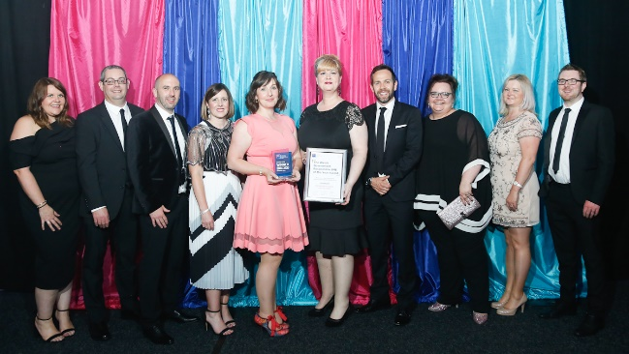
Rhondda Housing Association is situated in the heart of the Rhondda, a stone’s throw away from Cardiff and the M4.
This is an exciting time to join our Assets and Compliance team in our Homes and Communities directorate. The successful candidate will lead the delivery and development of innovation in asset management and have a key role in taking forward the Association’s decarbonisation agenda.

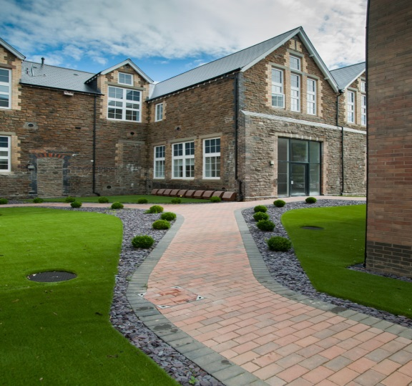
Our vision, values and behaviours are at the core of everything we do. We want a dynamic, outcome focussed individual who is committed to helping us to deliver excellent services and quality homes for our tenants.
In return, we offer generous leave and benefits, have an award-winning health and wellbeing programme and flexible working available; all making Rhondda Housing Association a great place to work!
If this sounds like the job for you, please visit email – jobs@rhondda.org - to request an information pack and find out more.

Closing date for application submission is Wednesday 20th November at midday.
Interviews will be held on 26th November 2019. Please ensure you are available on this date prior to applying.

No agencies please

Job Description

Post: Building Surveyor (Futures and Innovations)
Reporting to: Head of Assets and Compliance
Salary: £33,000

JOB PURPOSE

To work with the Head of Assets and Compliance to drive the delivery and development of innovative approaches, products and projects in asset management to ensure that the Association’s homes are fit for purpose now and into the future.

MAIN DUTIES AND RESPONSIBILITIES

- Identify new opportunities, incubate ideas and evaluate and embed new ways of working in relation to asset management and development, including voids, stock condition surveys, energy efficiency, methods of construction, IT systems and digital transformation.

- Critically assess and positively challenge current service delivery methods and implement any changes to improve performance, reduce costs and improve value for money.

- Responsibility for overseeing and delivering projects at different points of the innovation cycle, identifying and securing funding where required.
- Identify opportunities to work collaboratively with other housing associations and organisations

- Assist the Head of Assets and Compliance in the procurement of planned maintenance contracts.

- Support the Head of Assets and Compliance to produce accurate reports and data in relation to the maintenance of the Association’s assets, including Welsh Housing Quality Standard and any other Welsh Government standards or targets.

- Work with the Director of Homes and Investment and the Head of Assets and Compliance to produce and deliver the Association’s Asset Management Strategy and related policies

- To support the Head of Assets and Compliance to procure and embed and maintain asset management IT software and databases

- To lead on the decarbonisation agenda, identifying new approaches and managing contracts to improve the energy efficiency and sustainability of the Association’s homes.

- Lead and advise on the smart home technology agenda, identifying new approaches and managing contracts as required

- Research and advise the Development Team on new and emerging methods of construction

General

- Pro-actively participate in performance management, working in accordance with the Associations values and behaviours to ensure a positive culture for all staff and tenants.

- Pro-actively working collaboratively with colleagues across the Association to ensure effective service for our tenants.

- In line with all Data Protection legislation, adhere to the highest standards of confidentiality and data management, following the Association’s processes at all times.

- Be aware of your own responsibilities under the Health and Safety at Work Act and other safety regulations to ensure that safe working practices and procedures are adopted at all times

- Champion and work at all times in accordance with the Association’s People Strategy, Health & Safety Policy, Equal Opportunities Policy, and any other relevant policies.

- Undertake relevant education and training appropriate to the role to support professional development to maintain the necessary skills and competencies to meet the requirements of the role.

- Undertake other duties as may be required, commensurate with the post’s grading or general level of responsibility, within the Association

Person Specification
 | Essential/ Desirable | A | I | P
Qualifications
GCSE education or equivalent through relevant training/experience. | E | X
Formal building/surveying qualification | E | X
Experience
Experience of working within a maintenance environment | E | X | X
Experience of working at a senior level or in an advisory capacity | E | X | X
Experience of thinking strategically in dealing with maintenance issues | E | X | X
Experience of engaging customers in the shaping of services | D | X | X
Experience of designing schemes with costing, programming projects and specification of works | E | X | X
Experience in managing documents for tender and advise on appointing contractors, designers and procurement activity. | E | X | X
Knowledge
Knowledge of regulations, and all statutory obligations in relation to existing properties, including asbestos, legionella, defective premises, CDM, WHQS etc
Knowledge of social housing and the future challenges the sector faces | E | X | X
Knowledge of identifying and analysing defects within buildings including proposals for repair | E | X | X | X
Knowledge of energy efficient homes, environmental impacts and sustainable construction | E | X | X | X
Understanding and commitment to equality and diversity | E | X | X | X
Health and safety and data protection polices and legislation applicable to the role. | D | X | X | X
Skills
Ability to carry out feasibility studies | E | X | X | X
Ability and confidence to offer advice and assistance to other members of the team. | E | X | X | X
Able to effectively communicate with customers and understand their needs | E | X | X | X
Effective time management skills. Able to work effectively under pressure, organise priorities and deliver objectives on time | E | X | X | X
Excellent verbal and written communication skills. | E |  | X | X
Confident IT user | E | X | X | X
Effective and positive relationships and networks with internal and external stakeholders. | E | X | X | X
Ability to improve on and find new ways of working to improve efficiency and effectiveness. | E | X | X | X
Effectively deal with conflict and potentially aggressive/volatile situations involving customers. | E | X |  | X
Ability to analyse data and prepare reports identifying trends and improvements. | D
Personal Qualities
Understanding and commitment to Association’s Equal Opportunities Policy | E | X | X | X
A high level of personal integrity, expressed through behaviour and conduct | E |  | X | X
Self-awareness and understanding of the need to be a role model for others. | E | X | X | X
Demonstrates Values & Behaviours in line with Rhondda Housing Associations | E |  |  | X
Willingness to work flexibly, including evening meetings. | E | X |  | X

KEY
A = Application Form I = Interview P = Probationary Period

Useful Information
Your Application

Thank you very much for downloading an application pack for the post of Homes Assistant. In this pack you’ll find plenty of information about the role, including a job description and person specification. The person specification is a key document as this tells you what we’re looking for in our recruitment.

You should address any of the criteria marked assessed at application when completing the personal statement, and it would be really helpful for us if you could deal with each criteria in turn. Please make sure that you give us examples of your experience to date – this may be from your past work experience, or perhaps through voluntary work you’ve done.

References

We ask for references that cover the last three years of your employment, so if you have had more than 2 jobs in that period, we’ll need additional referees. These can be provided on a separate sheet.

Personal Details and Equality Monitoring

Before we shortlist, your personal details and Equal Opportunities Monitoring Form are separated from your application form. This is because we want to make sure that candidates are shortlisted on their knowledge, skills and experience alone.

Closing Date and Shortlisting

The closing date for this post is midday on Wednesday 20th November 2019. We will not be able to accept applications after this time.

The Selection Process

Interviews will be held on 26th November 2019. Please ensure you are available on this date prior to applying.
Applications should be submitted by email to jobs@rhondda.org

Terms & Conditions
Salary:
The salary for this post is £33,000 per annum.
Pension:
RHA is a member of the Social Housing Pension Scheme, and we offer a Career Average (CARE) defined benefit scheme. Our contribution is 13.4%, and employees contribute between 5% and 8%.
Holiday Entitlement:
25 days per annum rising to 30 days after 5 years’ service.
Working Hours:
Our normal working hours are 36.5 per week, however the post holder will be required to work such hours, and at such times as are necessary to carry out their duties.
Probation and Notice Periods:
The probationary period for this post is 6 months and can be extended to 12 months.
During the probationary period, the notice period on either side is 1 week. Upon successful completion of the probationary period, the notice period will be 1 months.
General:
This post will be based at our head offices - Ty Gwyn Newydd, 9 Compton Road, Tonypandy CF40 1BE. Travel may be expected across the borough, and elsewhere as necessary.

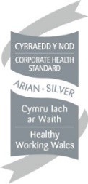
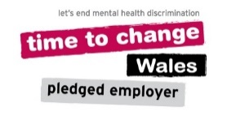
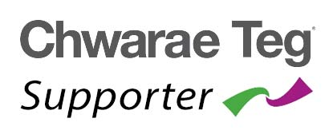
Our Benefits Package

