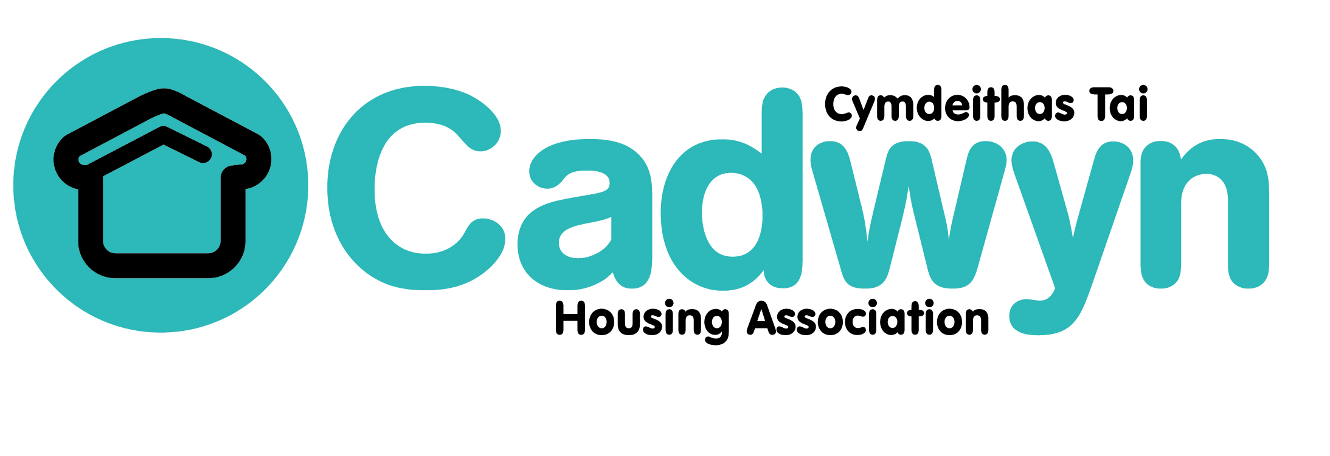
IT Manager
Job Specification
Department: IT
Responsible to: Director: Corporate Services
Responsible for: 1 x Senior IT Officer
2 x IT Officers
1 x BI Developer
1 x Data Privacy Officer
Hours of work: 35 hours
Job purpose
To deliver an effective, reliable, and secure IT service that supports the organisation to achieve its objectives, including the development of digital services.

Key outputs of the role:
- Provide expert strategic knowledge and inspirational leadership, training and
coaching to the IT team.

- Define, plan, and deliver the Digital Strategy, to include the development of digital services, optimising systems from the perspective of staff, tenants, and board members.

- Be responsible for implementing innovative ways to motivate teams to engage in digital systems and technology solutions, share insight and intuition to ensure digital capability is at the forefront of Cadwyn’s wider consideration, planning and culture.

- Advise and promote digital services with our tenants and key stakeholders.

- Ensure highest standards of cyber security to ensure effective systems are in place both to protect against and to monitor for potential or actual data loss or security breaches.

- To be responsible for the operational, strategic planning and provision of resource for the delivery of projects and support across the organisation.

- Manage tender processes in relation to IT hardware, networks, and security,
telephony, printer hardware and service together with software solutions. Oversee the implementation of these and ensure future needs are anticipated.

- Manage the IT budget and ensure value of money in accordance with Cadwyn’s Standing Orders and Financial Regulations.

- To lead the development and implementation of best practice processes within the IT team, maintaining systems and data in accordance with relevant legislation and protecting the Cadwyn’s data assets.

- Manage the relationship with external suppliers and service providers, ensuring that service levels are achieved within agreed budgets.

- Responsible for the technical elements of business continuity and disaster recovery plans for core infrastructure services and all office and data centre locations, and ensure regular tests are carried out.

- Take accountability for escalated issues and incidents, ensuring prioritisation of technical resources to achieve desired outcomes.

- Ensure Cadwyn is compliant with GDPR and other relevant regulations.

- Provide high quality, accurate, reliable, and timely information and reports to the Board and Executive Team.

- Maintain strong and effective working relationships with Cadwyn staff at all levels, board members, and tenants ensuring the effective and appropriate use of all resources to improve service delivery of the IT department.

