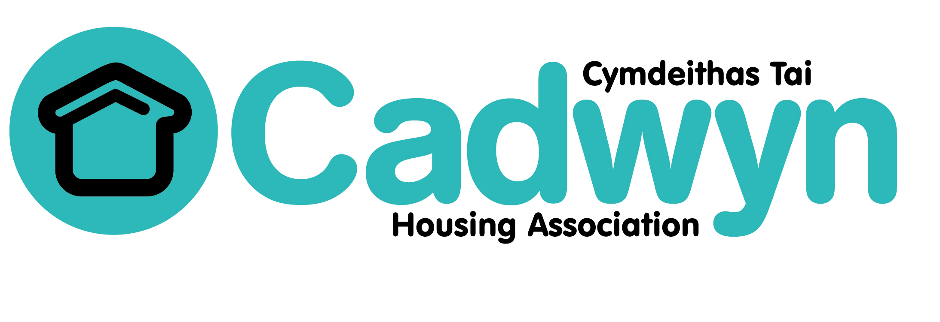
IT Manager
Person Specification

 | ESSENTIAL | DESIRABLE  (nice to have)
Qualifications | - Qualified to Degree Level or equivalent professional qualification in ICT. | - Project management qualifications
Experience | - Demonstrable extensive experience working within an IT department.  - Demonstrable evidence of influencing positive change within an IT function, including project management.  - Successful leadership and management of a high performing staff team.  - Experience of using Microsoft SQL Server | - Experience with Power Bi.  - Experience of handling and organising sets of data to develop high quality reports or dashboards.  - Management experience in an organisation of a similar size or in the Housing sector.
Knowledge | - Knowledge of best practice in relation to maintenance, support and delivery of IT systems and services.  - A good understanding of Information Security and Information Security principles, and GDPR  - Knowledge of SharePoint.  - Thorough knowledge of Windows operating systems.  - A clear understanding of the role of IT and digital transformation in the delivery of business outcomes in today’s climate. | - Understanding of current and future challenges facing registered social landlords  - Knowledge of best practice approaches to data representation, relational databases and data governance.
Skills | - Excellent leadership skills including the ability to motivate and develop staff in a challenging and pressurised environment.  - Ability to plan, develop, monitor, evaluate and audit systems to ensure effective implementation and development of projects and processes  - A clear understanding of the role of IT and digital transformation in the delivery of business outcomes
Personal Attributes / Abilities | - Excellent time management skills, with a proven track record of prioritising and planning effectively  - Strong customer focus, and desire to build a service around the needs of the business.  - Ability to work under pressure and deal with changing, varied priorities  - A high level of personal integrity, expressed through behaviour and conduct  - Self-awareness and understanding of the need to be a role model for others.  - Willingness to support the Values of Cadwyn | - A desire to provide value for money, and a utilise existing products to solve business needs.

