Melin Homes Limited | 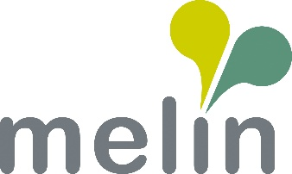
Job Description
Energy Advisor
Responsible to: Team Leader, Income & Inclusion
Job Grade: Officer
Purpose: To provide expert advice on energy efficiency and assist contract holders to make informed decisions about energy use.
As a qualified Energy Advisor, you will be responsible for analysing energy consumption patterns, and recommending strategies to improve energy efficiency. You will work closely with clients to understand their energy needs and provide tailored solutions that reduce environmental impact and save costs.

Duties & Responsibilities:

- Stay up-to-date with the latest energy-saving technologies and government incentives.
- Provide comprehensive and accurate advice on energy and water debt, fuel poverty, and energy efficiency using a casework management system.
- Liaise with energy and water providers on behalf of contract holders to put affordable payment plans in place.
- Represent contract holders when liaising with energy complaints to energy companies and the ombudsman.
- Advice on a range of topics including, affordable warmth, energy grants and water efficiency.
- Provide information, advice, guidance and practical support, to other team members across the whole range of energy related issues.
- Using a ‘person centred approach’, you will be deliver advice services in a clients’ home, community venue or any appropriate setting, and you must have the ability to travel independently.
- Demonstrate a commitment to customer care, safety, privacy and equality by complying with all relevant policy and procedures, in particular those relating to;
- Health & Safety Legislation – to ensure that safe working practices and procedures are adopted at all times.
- GDPR legislation – to act in compliance with GDPR and data protection laws, ensuring adherence to GDPR standards. respecting confidentiality and privacy, and protecting data subjects’ rights.
- Equality & Diversity – supporting the principles and practice of equality of opportunity as set out in the Association’s Equality & Diversity Policy.
To undertake any other relevant duties as determined by the Line Manager, Association or Chief Executive.

To undertake information systems duties as determined by the Director of Business Support or Technology Manager and advise on issues that will impact on the Association’s systems

Signed by Postholder |  | Date

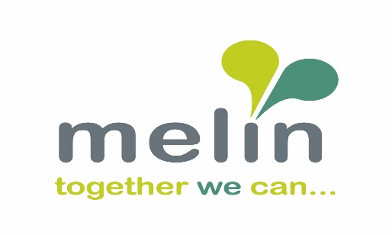

PERSON SPECIFICATION

Energy Advisor – Income and Inclusion Team

FACTORS | CRITERIA | ESSENTIAL / DESIRABLE
Education; Training and Experience | Experience of delivering advice and support to contract holders in their own homes or community setting. | E
 | Knowledge of available energy grants and funding. | D
 | Experience of managing a caseload and use of a casework management system. | E
 | Experience of working in a Housing Association environment and supporting contract holders to live better lives. | E
 | Able to advise and support other staff with energy related issues. | D
 | NVQ level 3 or higher in Energy Advice or willing to work towards it. | D
 | Experience of supporting people with their energy bills including fuel debt, fuel poverty, energy efficiency and grant funding. | D
 | Experience of working to targets to deliver KPI’s and outcomes | D
 | Communicate with energy companies and Ombudsman regarding energy issues on behalf of contract holders. | D
 | Knowledge of welfare benefits and Universal Credit and the impact on residents | D
Knowledge | Knowledge of energy industry and impact it has on contract holders. | D
 | Awareness of General Data Protection regulations and how it impacts on our work with residents | E
 | Understanding of and commitment to equal opportunities both in service delivery and employment. | E
 | Excellent communication skills, both verbal and written. Flexible, can adapt to changing work priorities at short notice, take on the ideas of others and implement organisational change in a positive way | E
 | IT literate including Microsoft packages and experience of using case recording databases. | E
 | Full, UK driving licence and use of own vehicle | E
Vision & Values | Experience of taking ownership and accountability, to show how your working practices align with our company values: Do the Right Thing, Find a Way, Make Things Happen, Make a Difference, Enjoy The Journey | D

