Melin Homes Limited | 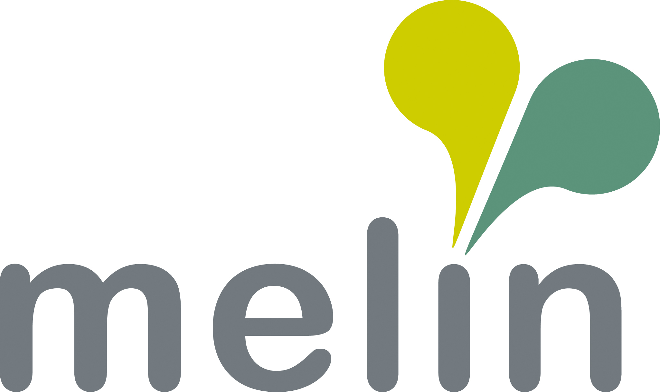
Job Description
Customer Contact Team Assistant

Responsible to: Customer Contact Manager

Job Grade: Assistant

Purpose: The Customer Contact Team Assistant will provide a courteous and efficient service to customers on a range of front-line customer services issues. The post holder will require a flexible approach to the post, working as part of a busy and committed team. The team will be jointly responsible for delivering a professional front line services to residents and provide administrative support to colleagues within People, Homes and Communities and anyone visiting or making an enquiry of the Association.

Duties & Responsibilities:

- To operate within a multi-channel contact centre, ensuring that queries via all channels are dealt with promptly and accurately on a first-time resolution basis. Assistant will update the Housing Management system with thorough details of resident contact.

- To provide comprehensive administrative support, enabling the effective delivery of services to residents. This includes using Contact Management to ensure that call back requests are made on behalf of residents if assistants are unable to answer queries.

- Deals with requests from customers who need repairs to their home and liaises with tenants to diagnose repairs and arrange suitable appointments, providing advice to residents on self-repair/tenant responsibility, identifying and advising on rechargeable repairs.

- Customer Service Advisors will have individual responsibilities for tasks allocated to them by the Customer Services Manager and Officers and will work on their own initiative to complete such tasks.

- To provide a professional Reception service to all visitors to and to deliver associated tasks including the sorting of mail and franking of post.

- To ensure that residents and prospective residents receive the maximum possible information about the services provided by the Association.

- To ensure continuous improvement, initiating, facilitating and responding to change in a positive manner.

- Utilise a Person-Centered Approach to deal with residents.

- Demonstrate a commitment to customer care, safety, privacy, and equality by
complying with all relevant policy and procedures, in particular those relating to:

- Health & Safety Legislation – to ensure that safe working practices and procedures are adopted at all times.
- GDPR legislation – to act in compliance with GDPR and data protection laws, ensuring adherence to GDPR standards. respecting confidentiality and privacy, and protecting data subjects’ rights.
- Equality & Diversity – supporting the principles and practice of equality of opportunity as set out in the Association’s Equality & Diversity Policy.

9. To undertake any other relevant duties as determined by the Line Manager, Association or Chief Executive.

Signed by Postholder |  | Date

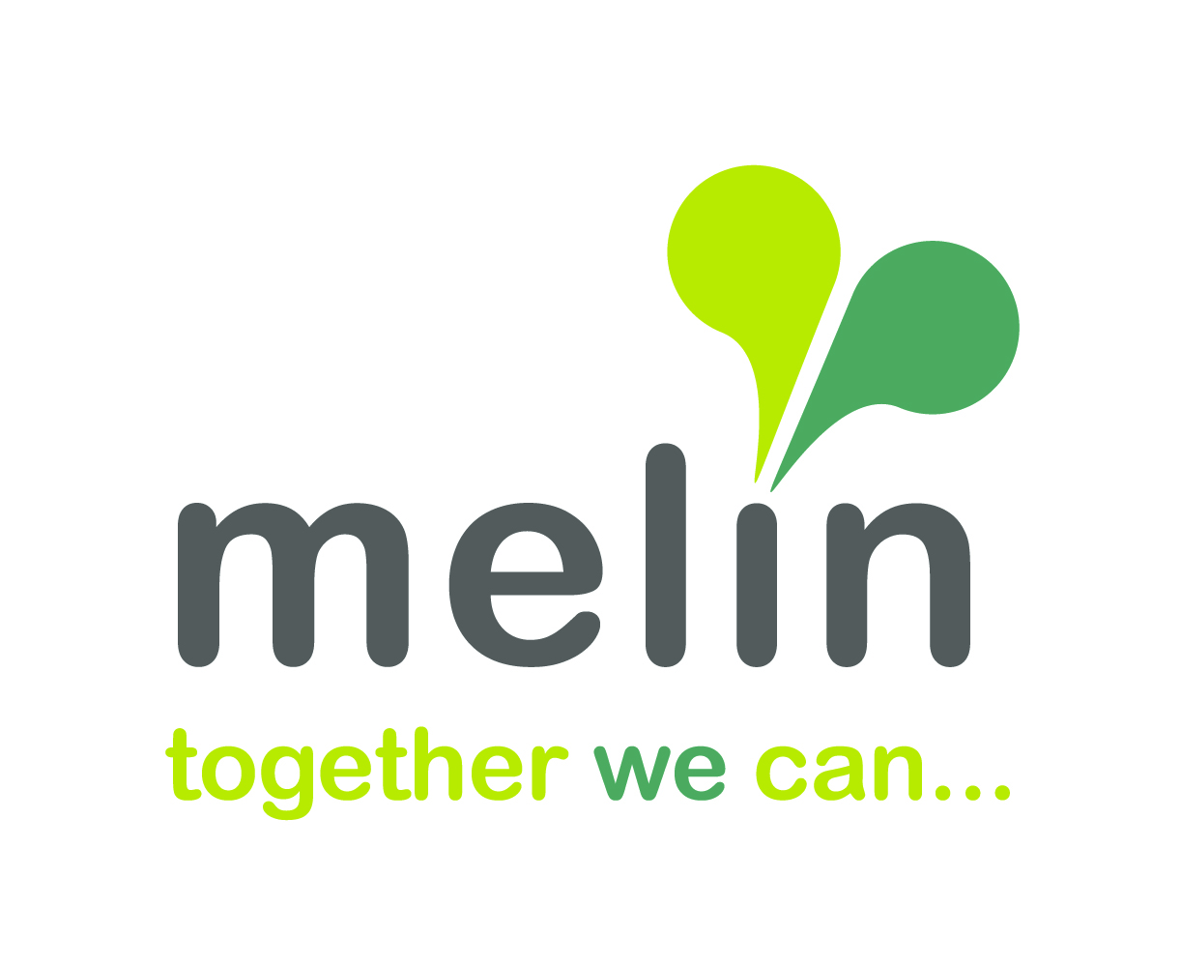

Person Specification

Customer Contact Team Assistant

Factors | Criteria | Essential or Desirable
Education, Training & Experience | Experience in using a variety of Microsoft Office packages | E
Education, Training & Experience | An awareness and working knowledge of equal opportunities | E
Education, Training & Experience | An awareness and working knowledge of, GDPR, confidentiality and safeguarding | E
Education, Training & Experience | Experience of working in a fast-paced contact Centre or customer focused environment | E
Education, Training & Experience | Experience of using various social media platforms in a customer focused environment i.e., Facebook, Live Chat etc | E
Education, Training & Experience | Current full driving license, ability to drive with access to a vehicle | E
Education, Training & Experience | An awareness and knowledge of health & safety | D
Education, Training & Experience | Experience of working in housing | D
Knowledge | An awareness of customer needs with the ability to display empathy and relate to vulnerable people | E
Knowledge | Customer Service | E
Knowledge | An understanding of using Person-centered approaches to support residents | D
Visions and Values | Experience of taking ownership and accountability, to show how your working practices align with our company values: Do the Right Thing, find a Way, Make Things Happen, make a Difference, Enjoy the Journey | D
Welsh Language | Fluent, Verbal and Welsh language skills | D

