**ClwydAlyn Housing**

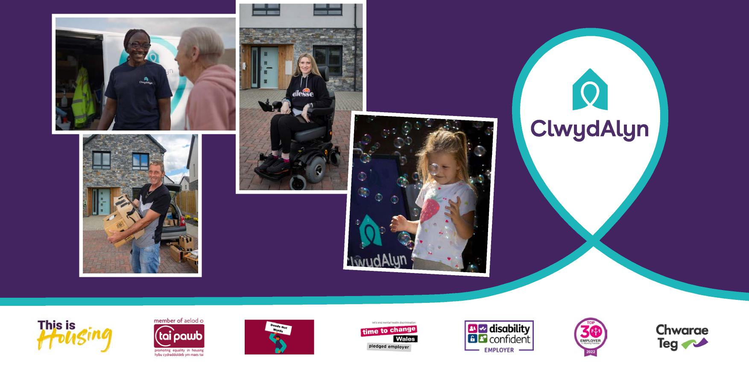

ClwydAlyn is a Charitable Registered Society

**Assurance Committee Member**

Recruitment Pack

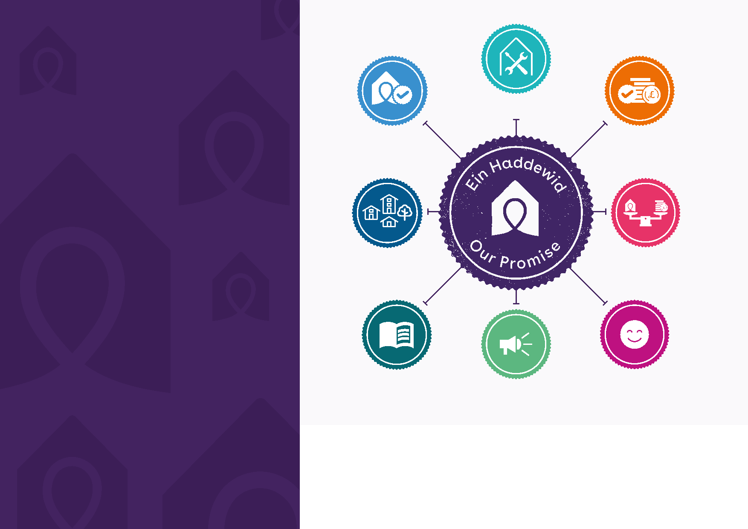

Make sure your home   
is affordable and   
support you with income   
and welfare advice.

Make sure we are   
well run and financially   
sustainable so we can

continue to tackle poverty.

Support you to live well in your home, so that you can live the life you choose in a safe and connected

community.

Making sure service   
charges are fair   
and provide value   
for money.

Provide excellent service   
and let you know how we   
are performing on essential   
maintenance, repairs   
and safety.

Spend money wisely and tell you how we spend it so that you can hold us to account.

Make sure your voice is heard,   
listen to your feedback, and deal with   
complaints quickly and fairly.

Make sure your home is safe,

secure and well-maintained.

Contents

Welcome letter 3

Our mission and Values ……………...4

About ClwydAlyn 4

Our governance structures 9

Meet the team 10

Who we are looking for 11

How to apply 12

We believe...

that having a safe, high-quality home really matters and a home should be more than just four walls and a roof. Our resident charter sets out our commitment to deliver excellent services to our residents and Our Promise was created in collaboration with our residents.

**Welcome letter**

Thank you for expressing an interest in **ClwydAlyn** and our vacancies for **Committee Members**. We are an ambitious housing association driven by our values and mission. We believe that it is wrong that there is still so much inequality and poverty across our region, and we know that this impacts every aspect of people’s lives.   
  
We took a unique position to end evictions five years ago and we use our money and influence to do all we can to support those experiencing poverty and to champion change across our country. We are a large developer of new homes with over 500 currently on site.   
  
We pride ourselves on building high quality homes, making them affordable for our tenants to live in and helping to reduce carbon emissions.   
  
We have built a number of innovative housing schemes utilising local Welsh builders; Welsh timber frames built in Berwyn prison and the latest air source heat pumps and battery technology etc. Our programme is 80% social housing, but we also build homes for intermediate rent and assisted purchase. We own 6,600 homes of various ages and types and are committed to an extensive programme of retrofit over the next 10 years.   
  
Developing a voice for residents is vital, and this is reflected in our governance structure. Residents are at the heart of our decision making and influence what we do and how we do it.   
  
  
We welcome feedback even when it is uncomfortable and want to do all we can to meet resident expectations.  
  
We are a strong believer in the benefits of collaboration and working in partnership. We have developed positive relationships at the local, regional, and national level.  
  
We have a credit rating and sufficient borrowing at fixed interest rates to fund our development programme for the next few years. We also have the highest regulatory ratings from Welsh Government for both finance and service delivery, and we have no formal improvement actions from recent Care Inspectorate Wales regulatory visits.  
  
Our priorities for the next few years include: developing an affordable and deliverable plan to reduce our carbon emissions; making sure that all our residents live in safe; high quality homes they can afford to heat; meeting the requirements of the Building Safety regime and investing more to address the impacts and causes of poverty in our communities.   
  
We want to be an exemplar of good practice for inclusion and diversity both as an employer and service provider.  
  
We are a top 30 employer across the UK for working families and offer our staff an exciting and fun place to work with a good rewards package and flexibility to manage their work and personal lives well. Our staff satisfaction levels are high, and we have replaced a number of   
  
  
policies with guidance allowing our managers to   
operate in a flexible person-centered way; whilst meeting business needs for service quality and performance.  
  
We have a committed and talented Board, supported by four Committees, an experienced, motivated Executive Team and committed, enthusiastic and talented staff. The information below provides you with a more detailed picture of the Group.  
  
We are centrally located along the North Wales corridor, 35 minutes from Bangor and Wrexham and an hour away from Manchester. In the last few years, we have significantly developed our approach to agile working and expect to continue to have a blended approach to meetings in the future.   
  
We are a very proud Welsh company and would welcome applications from Welsh speakers, and members of minority and diverse communities.  
  
If you are passionate about our mission and values, then we really look forward to hearing from you.

Cris McGuinness

Chair, ClwydAlyn Board

**Our mission**

The pace of change within the housing sector presents both significant opportunities and challenges. We’re an agile organisation that proactively adapts to change. We challenge thinking and we’re bold and open with our conversations.

We are creative and imaginative in overcoming new challenges, finding and maximising new opportunities in our mission to beat poverty, whilst also delivering excellent services for our residents. Our strategy is underpinned by financial leadership and management, delivering agreed annual surpluses to invest in our homes and services. We meet our financial covenants, and we deliver value for money.

**NO POVERTY.** Imagine how different Wales would be if we had no poverty. Everyone having access to high quality, affordable housing, able to afford to heat their home properly and afford the food they need to stay healthy. It might sound far-fetched, but at ClwydAlyn we don’t think so. We believe that we can and should aim to make this a reality for as many people as possible.

Our mission is ambitious, but by working together with external partners, we believe that we can tackle poverty. The continuing cost of living pressures means the stresses and strains faced by everyone are becoming harder to deal with. We have a clear responsibility to our residents and staff to support them. Our mission is more important than ever.   
  
We’re so much more than a social housing provider. We make a significant contribution to the North Wales economy both as an employer and as an investor, using as many local companies as possible and maximising the social value of every pound we spend.

To find out more about what we do please read our latest environmental, social and governance report here:

<https://www.clwydalyn.co.uk/documents/>

**About ClwydAlyn**

**ClwydAlyn** was formed in 1978 as a non-charitable Registered Social Landlord and now manages over 6,600 homes and employs 760 staff, to deliver a range of housing management related services, which includes care and supported housing, development, and repair and maintenance services across North Wales (Denbighshire, Flintshire, Conwy, Wrexham, Powys, Gwynedd and the Isle of Anglesey).

Our homes and services include social family housing and single person accommodation, supported living accommodation and specialist care and nursing services, low-cost home ownership, leasehold management services and intermediate and market rented housing. The Group’s turnover is £64m.



**Our people & values**

Our values of **Trust**, **Hope** and

**Kindness** drive everything we do.

We know we are only as good as our people, and we want the best to work with us. We’re proud to bring together people of all backgrounds and experiences, who work together to solve problems and make a difference.

**We trust our people to make good decisions and to do what’s right in a given situation.**

We treat each other with respect. We are not rule bound and we are free to work flexibly and creatively in the best interests of our residents and the

organisation.

**Trust Hope Kindness**

**We believe we can make a difference. We provide hope to the people who live in our homes and to each other.**

We believe that everyone comes to work to do the best job possible, and we’ll help each other to achieve our dreams and goals.

**We are kind.**

**We are compassionate and care for each other, as colleagues and residents.**

We believe everyone matters, and we have an open culture which values differences. We will go the extra mile for each other; our people and residents will recognise kindness in the way we deliver our services.

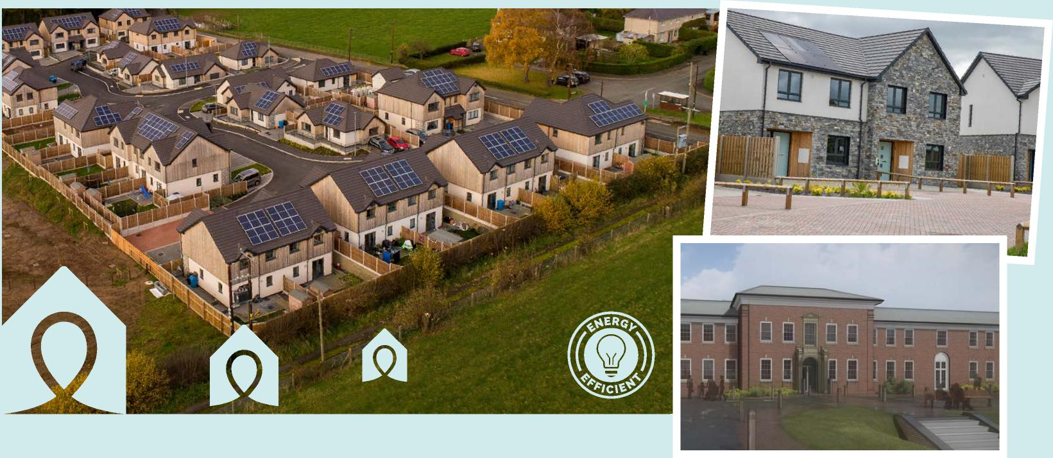

**Our Homes**

Our longer-term development plans are ambitious and underpinned by our Growth Strategy. 1,046 new homes have been delivered since 2017 by utilising our Bond. By the end of 2028/29, our portfolio will have reached over 8,000 homes, including social and affordable rented homes, affordable home ownership, and other housing tenures where it benefits the business and meets our values. The Programme consists of new build and refurbishment projects including listed buildings.

Our development programme provides major local benefit through investment in local trades, suppliers, training, and apprenticeships and supports the Welsh economy. Most new homes will be ‘off gas’ using air source heating systems and other environmentally sustainable ways of heating. Over 240 new homes will be ultra-low carbon, using off site manufacturing and low embodied carbon construction processes. All our new homes achieve an EPC A rating, are lifetime homes and built to the Welsh Government’s generous space standards.

https://www.clwydalyn.co.uk/our-developments

Reduce   
fuel poverty

Together   
to beat   
poverty

Increase   
employment,   
training, education   
and volunteering

Reduce   
food poverty

Increase   
digital inclusion

**Social Value Scope**

Activities and services that go beyond to deliver social value outcomes that contribute to our poverty priorities and mission to beat poverty.

**Our social value framework focuses**

**on our four poverty priorities**

**Our social purpose**

Providing social value is key to what we do. We want to make sure that every pound is spent as effectively as possible so we can have a bigger impact on our communities.

Our social value strategy takes a proactive approach to ensuring social value is embedded across the organisation and sits at the heart of our procurement plans.

**Our social purpose**

Providing social value is key to what we do. We want to make sure that every pound is spent as effectively as possible so we can have a bigger impact on our communities.

Our new social value strategy takes a proactive approach to ensuring social value is embedded across the organisation and sits at the heart of our procurement plans.

**Our social value framework focuses**

**on our four poverty priorities:**

Our poverty priorities

Our Mission

for residents

Increase   
employment,   
training, education   
and volunteering

Together,   
to beat   
poverty

Reduce food poverty

Reduce fuel poverty

Increase digital inclusion

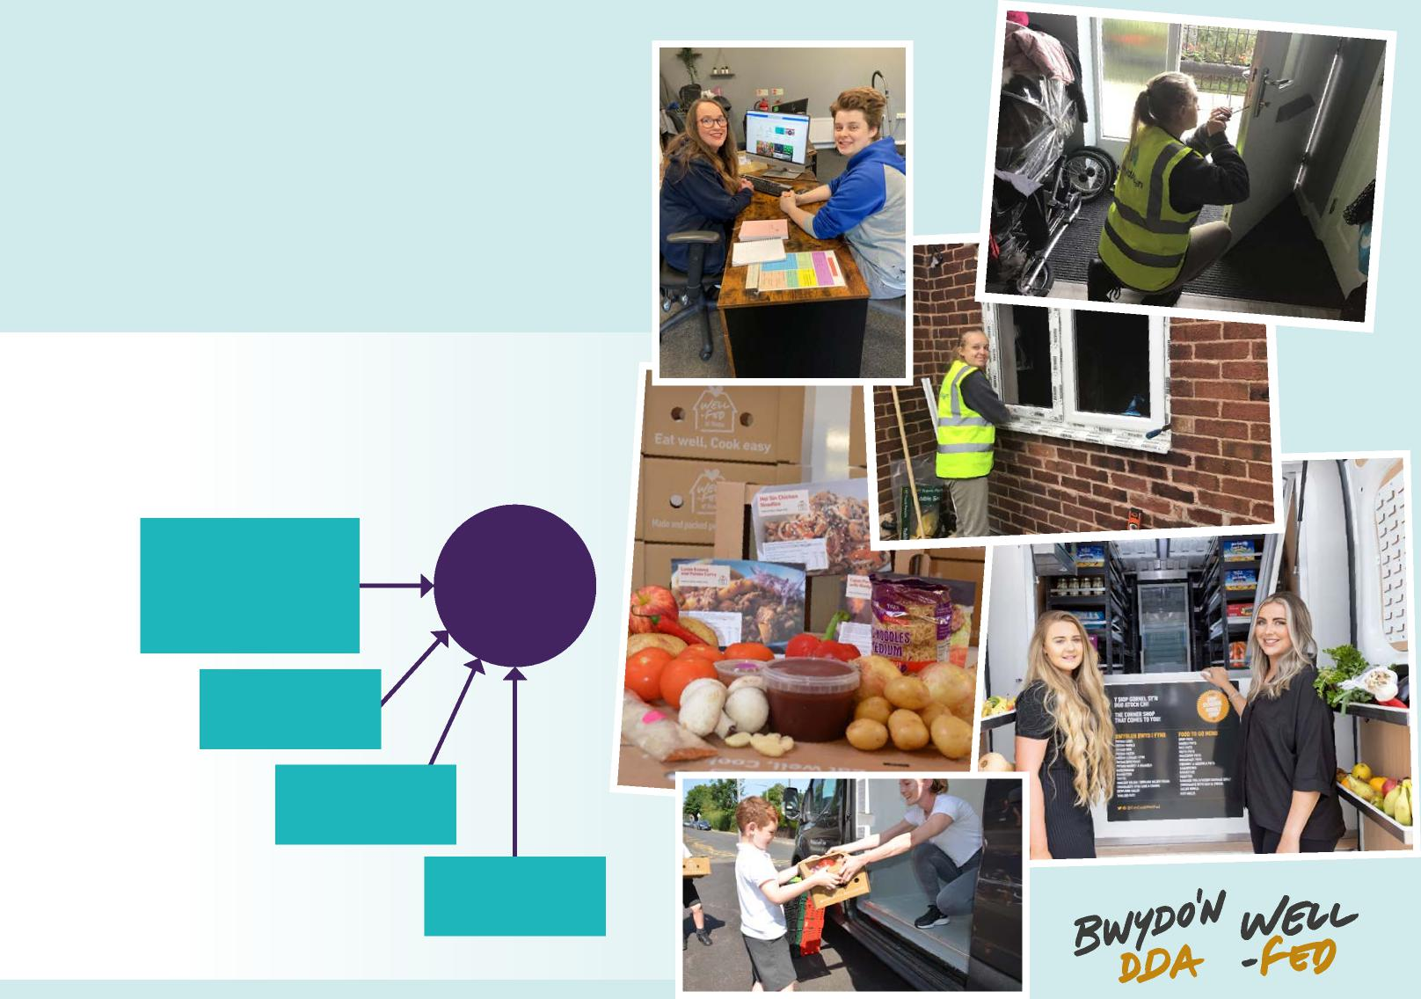

|  |  |
| --- | --- |
| **Our Regulation**  The Welsh Government oversee and monitor social housing in Wales to ensure our tenants are protected.  The Regulatory Framework is built upon the principle of co-regulation where autonomy and independence of Boards and effective regulation ensures we are:  **Well-governed -** led effectively and well managed by our board, executives and staff, working with tenants and partners to make and implement effective business decisions.  **Delivering high quality homes and services -** providing homes and services that meet people’s diverse needs and expectations, with an emphasis on high quality services and continuous improvement.  **Financially viable -** with well-managed finances, and the resources and cash flow to meet current and future business commitments. |  |

**Our recent Welsh Government’s Regulatory Judgement is the highest possible and confirmed as:**



**Financial Viability**

**GREEN**



**tenant services**

**Governance**

**Including**

**GREEN**

**Governance (including tenant services) Green and Compliant**

The association meets the regulatory standards and will receive routine

regulatory oversight.

**Financial Viability – Green and Compliant** The association meets regulatory standards and will receive routine regulatory oversight.

Our Care and Nursing Homes are regulated by Care Inspectorate Wales (CIW). CIW are an independent regulator of social care who inspect to improve the quality and safety of services for the well-being of its residents. We have three homes under this regulatory regime.

We are regulated by the Financial Conduct Authority for the debt advice we provide to our residents. Part of the Chair’s role will be as the responsible person for the activities carried out by ClwydAlyn.

The association meets the regulatory   
standards and will receive routine   
regulatory oversight.

**Our Governance and Legal Structure**

Our Group consists of **ClwydAlyn Housing**, the parent and principal operating company, and three subsidiaries, **PenArian**, **Tir Tai** and **Tai Elwy**.

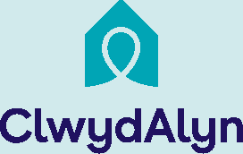

**ClwydAlyn Housing Limited**

A charitable Registered Social Landlord which develops, owns, manages and maintains housing, as well as providing housing and care & support services

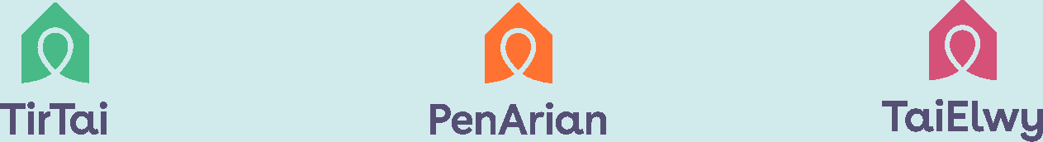

**Tir Tai Limited**The development arm of the Group, undertaking   
all the development activities on behalf   
of the Group.

**PenArian Housing Finance Plc**A special purpose vehicle set up to   
administer the £250m bond finance   
to the group.

**Tai Elwy Limited**The commercial vehicle to undertake activities   
and projects outside of ClwydAlyn’s charitable   
aims – particularly without grant funding.   
(currently Dormant)

**Our Board and Committees**

The **ClwydAlyn Board** is supported by four Committees - the Assurance Committee, the People Committee, the Property Committee and the Resident Committee.

**Assurance Committee**

The Assurance Committee provides assurance on the effectiveness of the Group’s internal control system (which includes risk management, operational and compliance controls), internal and external Audit, health and safety, financial reporting and Care Inspectorate Wales compliance.

**People Committee**

The People Committee provides the Board with assurance that the organisational climate and culture is operating and developing in keeping with the group’s values and mission to fulfil our purpose and manage risks well.

**Property Committee**

The Property Committee provides the Board with assurance on the quality, value for money and performance of investment in both building new homes and maintaining existing homes.

**Resident Committee**

The Resident Committee provides the Board with assurance on resident engagement, resident scrutiny, performance on services to residents and resident influence on services.

<https://www.clwydalyn.co.uk/meet-the-team/?department=executive-team>

<https://www.clwydalyn.co.uk/meet-the-team/?department=assurance-committee>

ClwydAlyn is led by a Board and Executive Team with a wide range of experience in relevant fields. They are responsible for leading the strategic direction and development of the Group. Further details about our Executive Team and Board and committee can be found on our website.

**Our Committee Members**

**Rob Morton – Board and Chair of the Assurance Committee -** Rob joined the Board in August 2019. Rob spent the early years of his career in the private sector before moving into Social Housing in 2014 and then into the Charity sector in 2023.

**Nia Wynne Hughes – Board and Assurance Committee Member** Nia started her career in audit at PWC and is a Fellow of the Association of Chartered Accountants. In 2015 Nia also became an Associate Member of the Association of Corporate Treasures. Since leaving PWC in 2010, she has gained experience in a number of finance roles in both the private and not-for-profit sectors. Nia currently works for Muir as Executive Director of Resources.

**Bethan Smith – Board and Assurance Committee Member** Bethan joined the ClwydAlyn Board in September 2023. Bethan is the Programme Manager in the Good Practice Team at Audit Wales. The role of the team is to improve public services. Bethan has over 15 years’ experience of working in the public sector in Wales, having previously worked in various roles across Social Services for Adults and Children at Flintshire County Council.

**Jen Griffiths – Assurance Committee Member** Jen joined the ClwydAlyn Assurance Committee in September 2023. Jen is a Service Manager at Flintshire County Council with responsibility for Housing, welfare and communities. Jen has worked in local government for over 30 years and has a wide range of experience in Housing, Poverty, systems leadership and partnership working.



**The Executive Team**

**EXECUTIVE LEADERSHIP STRUCTURE**

**Executive Director of Housing Services - Suzanne Mazzone**

**Executive Director of Development - Craig Sparrow**

**Executive Director of Resources – New appointment - 01/10/2024**

**Executive Director of Care & Support - Ed Hughes**

**Meet the Team**

**Group**

**Chief Executive**

**Clare Budden**

**Executive Director of People, Communications and Marketing -**

**Sian Williams**

Health and Safety

Legal

IT, Cyber and Data Protection

Governance and Risk

Programme and Project Management

Internal Audit

External Audit

Participate effectively in discussions, decision-making, and planning of the Group’s work, setting objectives and monitoring performance against these.

To monitor, guide and influence and provide the Board with assurance that decisions taken are in the best

interests of ClwydAlyn. Committee Members should demonstrate integrity, objectivity and accountability

and act in the best interests of ClwydAlyn and its Board and Committee.

It is important to us that the Board reflects the views of our diverse communities, we know that people from diverse backgrounds and communities makes us better at what we do. This means building a more inclusive and diverse Governance structure and promoting equality for all regardless of what you look like, where you come from and who you love. We are an equal opportunities employer and welcome applications from everyone.

Ability to make informed decisions, think strategically and challenge where necessary.

Provide scrutiny and ensure corrective action is taken, where necessary.

Collective knowledge and experience of the items delegated to the Committee

Ability to understand financial information and evaluate associated risk

A passion for our purpose and mission and upholds the values, objectives and core policies

Contributes to, and shares responsibility for, Committee decisions and adds value to the dialogue of the Committee and contribute to and share responsibility for decisions.

Ensure compliance with regulatory and relevant legislation and ensures the highest standards of corporate governance and financial probity.

Prepare appropriately for and attend Committee meetings regularly (a target of 80% has been set for this), training sessions, and other related events.

Ability to recognise wider business opportunities, sector risks and pressure points specific to the industry and Committee in order to deliver our objectives.

**Committee Member - Person Specification**



**Purpose**

**Key Responsibilities Essential**

Articulates opinions in a clear and concise manner.

We would particularly welcome applicants with

Experience of the Welsh Housing and Regulatory context and a sound understanding of the issues it faces.

experience and or skills in the following: areas:

**Desirable**

**You can apply in a number of ways:**

**The more traditional approach**

Send an up-to-date CV which shows your full career history and a statement explaining why you are interested in this role and the skills and experience you can bring to the role.

**Send us a short film**

Maximum 5 minutes explaining why you are interested in this role and the skills and experience you can bring.

Please send your CV or short film to [**Rachel.storr-barber@clwydalyn.co.uk**](mailto:Rachel.storr-barber@clwydalyn.co.uk)

Applications must be received by the 30th of September 2024. Applicants will be invited for interview with The Chair of the Assurance Committee, CEO and Executive Director of Resources.

These interviews will take place on

18th October 2024 at our offices in St Asaph.

**If you would like an informal chat about the position please call Clare Budden, CEO, on 07909 893520.**

Want to know more about our mission and what it’s like to be part of the team? Visit - https://www.clwydalyn.co.uk/who-we-are

**Your Commitment**

Acts wholly in the best interests of ClwydAlyn.

Four Committee meetings annually

Represent ClwydAlyn to further its mission

Annual visit to our homes

On-going personal development and representation at conferences, seminars, formal / informal training is essential. In addition, there is an annual appraisal conducted by the Chair of the Assurance Committee.



values, and purpose

Make time to prepare, attend and contribute Committee meetings both virtually and face to face

Commitment to our tenants, ensuring they are at the heart of everything we do

Respect diversity, inclusion, and value the contribution difference brings

Commitment to strategic away-days, training, and development

Commitment to our vision,

**Our Meetings**

We have a blended approach to our meetings via Teams and at our offices in St Asaph. Strategic awaydays are held off site at one of our schemes or suitable location.

**Remuneration**

This position attracts £2,800 per annum. Renumeration is reviewed every three years by the People Committee to ensure that it remains in line with sector norms. Members may claim for mileage at a rate of 45p per mile and certain other expenses incurred in fulfilling their role.

**Training**

Training is important and Members are invited to attend an initial induction (at a mutually agreed time) and ongoing continuous professional development is provided.

We are committed to building a healthy, vibrant, and inclusive organisation that treats people with respect and creates opportunities for all.

We particularly encourage applications from individuals who are from diverse backgrounds that are currently under-represented. Those with the ability to speak Welsh are particularly enhancing the Board’s Welsh language skills, knowledge and understanding of bilingualism, will help deliver better services for everyone.

**How to Apply**

Thank you very much for your interest in this role.