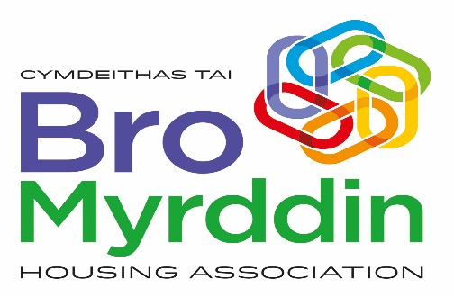

**EQUALITIES MONITORING FORM**

Bro Myrddin Housing Association wants to meet the aims and commitments set out in its equality policy. This includes not discriminating under the Equality Act 2010, and building an accurate picture of the make-up of the workforce in encouraging equality and diversity.

All the information you give is stored confidentially either on electronically or as manual records and will not be used in any way that could lead to individuals being identified. We will report the results of this monitoring to the Board of Management. We will not use this information for any other purposes or reveal it to any other organisations without your permission except under statutory obligations. The organisation needs your help and co-operation to enable it to do this, but filling in this form is voluntary. Information provided will be treated in accordance with the General Data Protection Regulation (GDPR).

|  |  |  |  |  |  |  |  |  |  |  |
| --- | --- | --- | --- | --- | --- | --- | --- | --- | --- | --- |
| **1. How would you describe your ethnic group?** | | | | | | | | | | |
| **White** | | | | | | | | | | **Please (✓)** |
| Welsh/English/Scottish/Northern Irish/British | | | | | | | | | |  |
| Irish | | | | | | | | | |  |
| Gypsy or Irish Traveller | | | | | | | | | |  |
| Any other white background  ______________________ | | | | | | | | | |  |
| **Mixed/multiple ethnic groups** | | | | | | | | | |  |
| White and Black Caribbean | | | | | | | | | |  |
| White and Black African | | | | | | | | | |  |
| White and Asian | | | | | | | | | |  |
| Any other Mixed/multiple ethnic background _______________ | | | | | | | | | |  |
| **Asian/Asian British** | | | | | | | | | |  |
| Indian | | | | | | | | | |  |
| Pakistani | | | | | | | | | |  |
| Bangladeshi | | | | | | | | | |  |
| Chinese | | | | | | | | | |  |
| Any other Asian Background ______________________ | | | | | | | | | |  |
| **Black/African/Caribbean/Black British** | | | | | | | | | |  |
| African | | | | | | | | | |  |
| Caribbean | | | | | | | | | |  |
| Any other Black/African/Caribbean Background | | | | | | | | | |  |
| **Other ethnic group** | | | | | | | | | |  |
| Arab | | | | | | | | | |  |
| Any other ethnic group_____________________ | | | | | | | | | |  |
| **Prefer not to say** | | | | | | | | | |  |
|  | | | | | | | | | | |
| **2. Gender** | | | | | | | | | | |
| Male | | | |  | Female | | | | |  |
| Intersex | | | |  | Non-binary | | | | |  |
| Transgender | | | |  | Prefer not to say | | | | |  |
| If you prefer to use your own term, please specify below: | | | | | | | | | | |
| **3. What is your age group?** | | | | | | | | | | |
| 16-24 |  | 25-29 |  | | | 30-34 |  | 35-39 |  | |
| 40-44 |  | 45-49 |  | | | 50-54 |  | 55-59 |  | |
| 60-64 |  | 65+ |  | | | Prefer not to say | | |  | |
|  | | | | | | | | | | |
| **4. Do you consider yourself to have a disability or health condition?** | | | | | | | | | | |
| Yes |  | No | |  | | Prefer not to say | | | |  |
| What is the effect or impact of your disability or health condition on your ability to give your best at work? Please write beneath: | | | | | | | | | | |
| **5. What is your sexual orientation?** | | | | | | | | | | |
| Gay woman \ lesbian | | | |  | Gay man | | | | |  |
| Bisexual | | | |  | Heterosexual | | | | |  |
| Prefer not to say | | | | | | | | | |
| If you prefer to use your own term, please specify below: | | | | | | | | | | |
| **6. What is your religion or belief?** | | | | | | | | | | |
| No religion or belief | | | |  | Buddhist | | | | |  |
| Christian | | | |  | Hindu | | | | |  |
| Jewish | | | |  | Muslim | | | | |  |
| Sikh | | | |  | Prefer not to say | | | | |  |
| If other religion or belief, please write beneath: | | | | | | | | | | |
|  | | | | | | | | | | |
| **7. What is your marital status?** | | | | | | | | | | |
| Single | | | |  | Married | | | | |  |
| Living with partner | | | |  | Divorced | | | | |  |
| Separated | | | |  | Same-sex civil partnership | | | | |  |
| Widowed | | | |  | Prefer not to say | | | | |  |
|  | | | | | | | | | | |
| **8. I do not wish to provide any of the information requested on this form** | | | | | | | | | |  |